THE M-TEER WORKBOOK
Draw · Sketch · Colour · Learn · Master
The Creative Companion to M-TEER Simplified
Designed during TEER Fellowship with
Prof. Francesco Maisano
CANDIDATE NAME:

TRAINING CENTRE:
San Raffaele University Hospital, Milan

Workbook Philosophy
“The hand that draws understands what the eye merely sees.”
This workbook is built on a single conviction: you learn the mitral valve best when you recreate it yourself. Every sketch you draw, every segment you colour, every diagram you annotate becomes a memory anchor no lecture can replicate.
This is not a colouring book for children — it is a deliberate learning tool for serious clinicians.

Workbook Structure at a Glance
Section | Theme | Activity Type
A | Know It | Anatomy drawing & labelling
B | See It | Echo tracing & interpretation
C | Map It | Pathology classification sketches
D | Plan It | Patient case planning pages
E | Do It | Procedural step visualisation
F | Fix It | Complication scenario mapping
G | Colour It | Full artistic colouring studio
H | Own It | Personal reflection & notes
How to Use This Workbook
- Work through sections in order during your fellowship, or jump to the module relevant to your current rotation.
- Keep a set of coloured pencils or fine-tip markers with you — colour coding is used throughout.
- Pair each module with the corresponding chapter in M-TEER Simplified for full context.
- Use the reflection boxes honestly — they are for you, not for assessment.
- Revisit completed pages after 3, 6 and 12 months — you will be surprised how your understanding deepens.

Table of Contents
Workbook Philosophy 1
Workbook Structure at a Glance 1
Table of Contents 1
MODULE A1 — The Mitral Valve Apparatus: Build It from Scratch 1
MODULE A2 — Scallop Segmentation Map 1
MODULE A3 — The Subvalvular World 1
MODULE A4 — The Mitral Valve in 3D Space 1
MODULE B1 — TEE View Tracing Library 1
MODULE B2 — Measure It Yourself 1
MODULE B3 — Jet Location Map 1
MODULE C1 — Carpentier Classification Drawing Pages 1
MODULE C2 — DMR vs. SMR Side-by-Side Sketch 1
MODULE C3 — Barlow's Disease Anatomy Map 1
MODULE D1 — The TEER Case Planning Sheet 1
MODULE D2 — The “TEER-able or Not?” Decision Tree Sketchpad 1
MODULE D3 — Challenging Anatomy Sketchbook 1
MODULE E1 — The Transseptal Puncture Map 1
MODULE E2 — Clip Positioning: The Approach Vector 1
MODULE E3 — The Double-Clip Strategy Map 1
MODULE E4 — The “Perfect Clip” vs. “Acceptable Clip” Illustration 1
MODULE F1 — Complication Recognition Cards 1
MODULE F2 — My Toughest Cases Log 1
MODULE G1 — “The Living Valve” — Full Anatomical Colouring Plates 1
MODULE G2 — The Echo Art Studio 1
MODULE G3 — Build Your Own MitraClip 1
MODULE G4 — The Heart Team Ecosystem — Visual Map 1
MODULE H1 — My Fellowship Timeline 1
MODULE H2 — “Maisano's Teachings” — My Personal Collection 1
MODULE H3 — My 100 Cases Log 1
MODULE H4 — Letter to My Future Self 1
Quick Reference Tools 1
The M-TEER Workbook Pocket Reference Card (detachable / laminate) 1
Pocket Reference Card — Side A: Anatomy Quick Map 1
Pocket Reference Card — Side B: Procedure Checklist 1

SECTION A
KNOW IT
Anatomy Drawing Modules
Understand the mitral valve as a connected system, one structure at a time.

MODULE A1 — The Mitral Valve Apparatus: Build It from Scratch
Learning Goal: Understand all six components of the mitral apparatus as a connected system.
Drawing Exercise — “The 6-Layer Build”
- Draw the annulus (saddle shape — hint: not flat!)
- Add the anterior leaflet (large, sail-like, A1–A2–A3)
- Add the posterior leaflet (smaller, 3 scallops: P1–P2–P3)
- Draw the commissures (AC and PC — the forgotten landmarks)
- Add primary, secondary, tertiary chordae tendineae
- Place the papillary muscles (anterolateral + posteromedial)
Drawing Canvas
Sketch the heart cross-section and build your 6-layer mitral apparatus here.

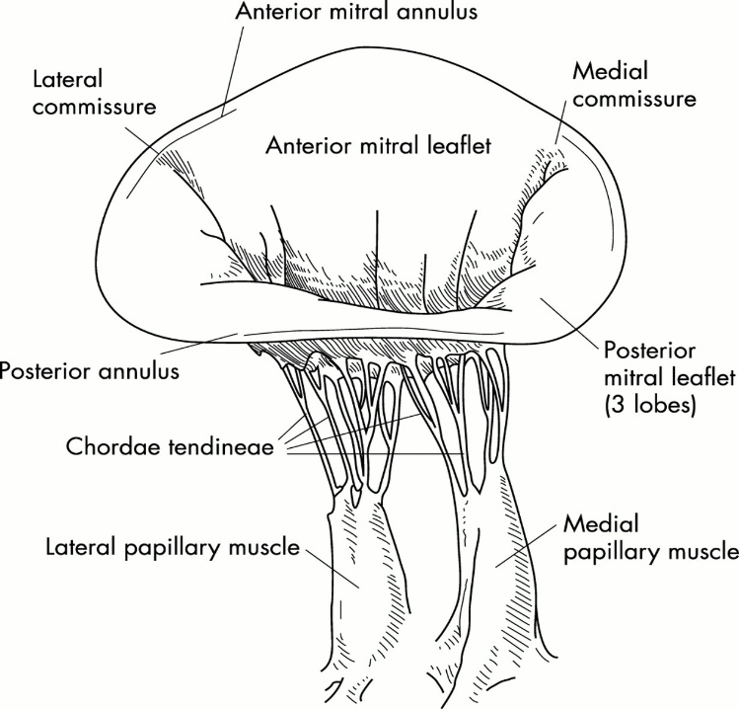

Colouring Key — apply these colours to your drawing above
Anterior leaflet
Posterior leaflet
Annulus
Chordae tendineae
Papillary muscles
Commissures
MAISANO MOMENT
“The annulus is saddle-shaped for a reason.
When you flatten it, you create disease. Nature’s geometry is the best teacher.”

MODULE A2 — Scallop Segmentation Map
The Carpentier Segmentation System: Colour & Label.
Surgeon’s view (from left atrium looking down)
Anterior Leaflet |  |  | Commissures
A1 | A2 | A3 | AC (anterolateral)
P1 | P2 | P3 | PC (posteromedial)
Candidate Tasks
- Colour each scallop a different shade in the drawing canvas below
- Mark the primary TEER target zone (A2–P2)
- Draw a MitraClip device at A2–P2
- Label the typical DMR prolapse location
- Label the typical SMR tethering pattern
Draw the en-face mitral valve and complete the tasks above.

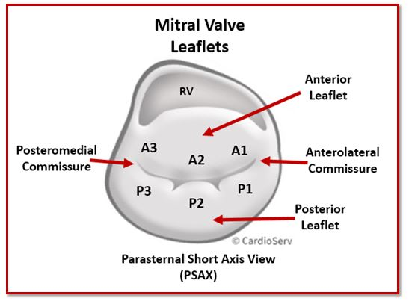

MODULE A3 — The Subvalvular World
Full-page blank cross-section for candidate to draw and label:
- Primary chordae (to leaflet edges)
- Secondary chordae (to leaflet bodies)
- Tertiary chordae (to posterior leaflet base)
- Anterolateral papillary muscle (dual blood supply)
- Posteromedial papillary muscle (single supply — why it ruptures in MI)
Sketch the LV cross-section with the full subvalvular apparatus.

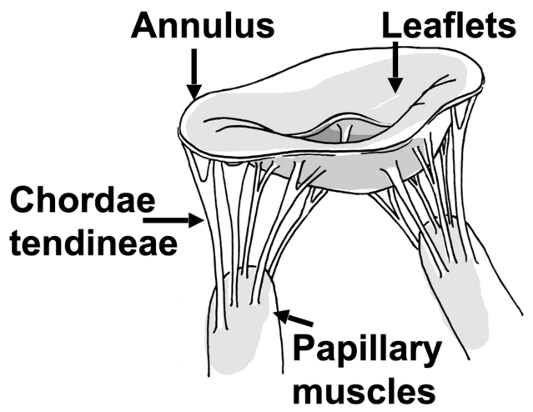

CLINICAL INSIGHT — Answer After Drawing
Why does the posteromedial papillary muscle rupture more often in inferior myocardial infarction?

MODULE A4 — The Mitral Valve in 3D Space
Perspective drawing exercise. For each view below, trace the valve as it would appear and note the corresponding probe angle.
1. En face (“surgical”) view from above
Trace the en-face view here.

2. Long-axis (parasternal echo) view
Trace the long-axis view here.

3. Bicommissural (TEE) view
Trace the bicommissural view here.

Match each view to its probe angle
View | Probe Angle (°) | Key Structures Seen
En face / surgical view | 3D reconstruction
Long-axis | 120–135°
Bicommissural | 60°

SECTION B
SEE IT
Echo Tracing & Interpretation Pages
You treat what you see — train your eye through your hand.

MODULE B1 — TEE View Tracing Library
For each of the 8 essential TEER TEE views, trace the key structures, label them, note the probe angle and depth, and write what you are specifically looking for in TEER planning.
View 1: Midesophageal 4-chamber (0°)
Probe Angle / Depth | Key Structures to Label | TEER Planning Purpose
Trace the echo image and label structures here.

View 2: Midesophageal commissural (60°)
Probe Angle / Depth | Key Structures to Label | TEER Planning Purpose
Trace the echo image and label structures here.

View 3: Midesophageal long-axis (120°–135°)
Probe Angle / Depth | Key Structures to Label | TEER Planning Purpose
Trace the echo image and label structures here.

View 4: Transgastric basal short-axis (“fish-mouth view”)
Probe Angle / Depth | Key Structures to Label | TEER Planning Purpose
Trace the echo image and label structures here.

View 5: Biplane imaging of A2–P2
Probe Angle / Depth | Key Structures to Label | TEER Planning Purpose
Trace the echo image and label structures here.

View 6: 3D en-face “surgeon’s view”
Probe Angle / Depth | Key Structures to Label | TEER Planning Purpose
Trace the echo image and label structures here.

View 7: Colour Doppler jet mapping
Probe Angle / Depth | Key Structures to Label | TEER Planning Purpose
Trace the echo image and label structures here.

View 8: Post-clip assessment view
Probe Angle / Depth | Key Structures to Label | TEER Planning Purpose
Trace the echo image and label structures here.

MODULE B2 — Measure It Yourself
Practice measurement worksheet — complete using a live case or recorded loop.
TEER Planning Measurement | Value | Unit
Coaptation gap |  | mm
Anterior leaflet length |  | mm
Posterior leaflet length |  | mm
Mitral valve area |  | cm²
EROA |  | cm²
Vena contracta |  | mm
Annular diameter (AP) |  | mm
Annular diameter (IC) |  | mm
Mean gradient (baseline) |  | mmHg
Post-clip gradient |  | mmHg
REPEAT THIS PAGE
Photocopy or redraw this table for at least 5 different cases during your fellowship — trend your own measurement accuracy over time.

MODULE B3 — Jet Location Map
For each case encountered in fellowship, draw the MR jet location and direction on the blank en-face template, classify the jet, note the likely mechanism, and record the date and a brief case description.
REMEMBER
“Ten cases drawn by hand = ten cases never forgotten.”

Jet Map — Case 1
Date | Brief Case Description | Classification (Central / Commissural / Eccentric) | Likely Mechanism (Carpentier)
Draw the en-face mitral valve and mark the jet location and direction.

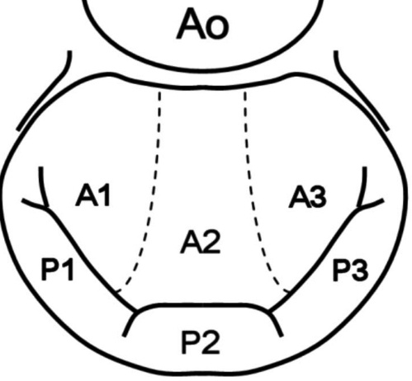

Jet Map — Case 2
Date | Brief Case Description | Classification (Central / Commissural / Eccentric) | Likely Mechanism (Carpentier)
Draw the en-face mitral valve and mark the jet location and direction.

Jet Map — Case 3
Date | Brief Case Description | Classification (Central / Commissural / Eccentric) | Likely Mechanism (Carpentier)
Draw the en-face mitral valve and mark the jet location and direction.

Jet Map — Case 4
Date | Brief Case Description | Classification (Central / Commissural / Eccentric) | Likely Mechanism (Carpentier)
Draw the en-face mitral valve and mark the jet location and direction.

Jet Map — Case 5
Date | Brief Case Description | Classification (Central / Commissural / Eccentric) | Likely Mechanism (Carpentier)
Draw the en-face mitral valve and mark the jet location and direction.

Jet Map — Case 6
Date | Brief Case Description | Classification (Central / Commissural / Eccentric) | Likely Mechanism (Carpentier)
Draw the en-face mitral valve and mark the jet location and direction.

Jet Map — Case 7
Date | Brief Case Description | Classification (Central / Commissural / Eccentric) | Likely Mechanism (Carpentier)
Draw the en-face mitral valve and mark the jet location and direction.

Jet Map — Case 8
Date | Brief Case Description | Classification (Central / Commissural / Eccentric) | Likely Mechanism (Carpentier)
Draw the en-face mitral valve and mark the jet location and direction.

Jet Map — Case 9
Date | Brief Case Description | Classification (Central / Commissural / Eccentric) | Likely Mechanism (Carpentier)
Draw the en-face mitral valve and mark the jet location and direction.

Jet Map — Case 10
Date | Brief Case Description | Classification (Central / Commissural / Eccentric) | Likely Mechanism (Carpentier)
Draw the en-face mitral valve and mark the jet location and direction.

SECTION C
MAP IT
Pathology Classification Sketches
Draw the mechanism, and the diagnosis follows.

MODULE C1 — Carpentier Classification Drawing Pages
For each type, draw the mitral leaflet motion and annotate the mechanism.
TYPE I — Normal leaflet motion
Sketch the MR mechanism (e.g., annular dilation, leaflet perforation).
Draw Type I mechanism here.

TYPE II — Excessive leaflet motion
Draw prolapse, flail, or chordal rupture. Mark which scallop is involved — A1? P2? A commissure?
Draw Type II mechanism here.

TYPE IIIa — Restricted motion (diastole AND systole)
Draw rheumatic thickening or calcification causing restriction.
Draw Type IIIa mechanism here.

TYPE IIIb — Restricted motion (systole only)
Draw tethered leaflets with papillary muscle displacement. Note: this is the SMR hallmark.
Draw Type IIIb mechanism here.

MODULE C2 — DMR vs. SMR Side-by-Side Sketch
Full double-page spread — draw both etiologies and compare directly.
DMR — Degenerative | SMR — Secondary/Functional
Draw the prolapsing or flail segment | Draw the tethered leaflets
Mark the chordal rupture if present | Mark the papillary muscle displacement
Sketch the LV: normal size/function | Sketch the dilated cardiomyopathy LV
Colour the jet direction (usually eccentric) | Colour the central or posterior jet
DMR — Drawing Canvas
Draw the DMR valve and LV here.

SMR — Drawing Canvas
Draw the SMR valve and LV here.

MODULE C3 — Barlow's Disease Anatomy Map
The complex anatomy challenge — map the following features:
- Bileaflet prolapse pattern
- Excess leaflet tissue (“billowing”)
- Annular dilation
- Multiple jet locations
Draw the Barlow's valve with all features above.

REFLECTION
Why does this anatomy make TEER technically demanding? What would Prof. Maisano weigh when comparing TEER vs. surgical repair here?

SECTION D
PLAN IT
Pre-Procedural Case Planning Templates
Every successful procedure begins on paper.

MODULE D1 — The TEER Case Planning Sheet
Use one copy per case during your fellowship. 20 copies are provided below.

M-TEER Case Planning Sheet — Copy 1
Field | Detail
Patient code
Age / Sex
MR etiology (DMR / SMR / Mixed)
NYHA class (I–IV)
EF (%)
STS score
Anatomy Sketch
Draw the valve anatomy here.

Field | Detail
Target zone
Clip strategy (Single / Double / Triple)
Clip size (NT / NTW / XT / XTW)
Transseptal height (target 3.5–4 cm)
Key challenges
Heart team decision

M-TEER Case Planning Sheet — Copy 2
Field | Detail
Patient code
Age / Sex
MR etiology (DMR / SMR / Mixed)
NYHA class (I–IV)
EF (%)
STS score
Anatomy Sketch
Draw the valve anatomy here.

Field | Detail
Target zone
Clip strategy (Single / Double / Triple)
Clip size (NT / NTW / XT / XTW)
Transseptal height (target 3.5–4 cm)
Key challenges
Heart team decision

M-TEER Case Planning Sheet — Copy 3
Field | Detail
Patient code
Age / Sex
MR etiology (DMR / SMR / Mixed)
NYHA class (I–IV)
EF (%)
STS score
Anatomy Sketch
Draw the valve anatomy here.

Field | Detail
Target zone
Clip strategy (Single / Double / Triple)
Clip size (NT / NTW / XT / XTW)
Transseptal height (target 3.5–4 cm)
Key challenges
Heart team decision

M-TEER Case Planning Sheet — Copy 4
Field | Detail
Patient code
Age / Sex
MR etiology (DMR / SMR / Mixed)
NYHA class (I–IV)
EF (%)
STS score
Anatomy Sketch
Draw the valve anatomy here.

Field | Detail
Target zone
Clip strategy (Single / Double / Triple)
Clip size (NT / NTW / XT / XTW)
Transseptal height (target 3.5–4 cm)
Key challenges
Heart team decision

M-TEER Case Planning Sheet — Copy 5
Field | Detail
Patient code
Age / Sex
MR etiology (DMR / SMR / Mixed)
NYHA class (I–IV)
EF (%)
STS score
Anatomy Sketch
Draw the valve anatomy here.

Field | Detail
Target zone
Clip strategy (Single / Double / Triple)
Clip size (NT / NTW / XT / XTW)
Transseptal height (target 3.5–4 cm)
Key challenges
Heart team decision

M-TEER Case Planning Sheet — Copy 6
Field | Detail
Patient code
Age / Sex
MR etiology (DMR / SMR / Mixed)
NYHA class (I–IV)
EF (%)
STS score
Anatomy Sketch
Draw the valve anatomy here.

Field | Detail
Target zone
Clip strategy (Single / Double / Triple)
Clip size (NT / NTW / XT / XTW)
Transseptal height (target 3.5–4 cm)
Key challenges
Heart team decision

M-TEER Case Planning Sheet — Copy 7
Field | Detail
Patient code
Age / Sex
MR etiology (DMR / SMR / Mixed)
NYHA class (I–IV)
EF (%)
STS score
Anatomy Sketch
Draw the valve anatomy here.

Field | Detail
Target zone
Clip strategy (Single / Double / Triple)
Clip size (NT / NTW / XT / XTW)
Transseptal height (target 3.5–4 cm)
Key challenges
Heart team decision

M-TEER Case Planning Sheet — Copy 8
Field | Detail
Patient code
Age / Sex
MR etiology (DMR / SMR / Mixed)
NYHA class (I–IV)
EF (%)
STS score
Anatomy Sketch
Draw the valve anatomy here.

Field | Detail
Target zone
Clip strategy (Single / Double / Triple)
Clip size (NT / NTW / XT / XTW)
Transseptal height (target 3.5–4 cm)
Key challenges
Heart team decision

M-TEER Case Planning Sheet — Copy 9
Field | Detail
Patient code
Age / Sex
MR etiology (DMR / SMR / Mixed)
NYHA class (I–IV)
EF (%)
STS score
Anatomy Sketch
Draw the valve anatomy here.

Field | Detail
Target zone
Clip strategy (Single / Double / Triple)
Clip size (NT / NTW / XT / XTW)
Transseptal height (target 3.5–4 cm)
Key challenges
Heart team decision

M-TEER Case Planning Sheet — Copy 10
Field | Detail
Patient code
Age / Sex
MR etiology (DMR / SMR / Mixed)
NYHA class (I–IV)
EF (%)
STS score
Anatomy Sketch
Draw the valve anatomy here.

Field | Detail
Target zone
Clip strategy (Single / Double / Triple)
Clip size (NT / NTW / XT / XTW)
Transseptal height (target 3.5–4 cm)
Key challenges
Heart team decision

M-TEER Case Planning Sheet — Copy 11
Field | Detail
Patient code
Age / Sex
MR etiology (DMR / SMR / Mixed)
NYHA class (I–IV)
EF (%)
STS score
Anatomy Sketch
Draw the valve anatomy here.

Field | Detail
Target zone
Clip strategy (Single / Double / Triple)
Clip size (NT / NTW / XT / XTW)
Transseptal height (target 3.5–4 cm)
Key challenges
Heart team decision

M-TEER Case Planning Sheet — Copy 12
Field | Detail
Patient code
Age / Sex
MR etiology (DMR / SMR / Mixed)
NYHA class (I–IV)
EF (%)
STS score
Anatomy Sketch
Draw the valve anatomy here.

Field | Detail
Target zone
Clip strategy (Single / Double / Triple)
Clip size (NT / NTW / XT / XTW)
Transseptal height (target 3.5–4 cm)
Key challenges
Heart team decision

M-TEER Case Planning Sheet — Copy 13
Field | Detail
Patient code
Age / Sex
MR etiology (DMR / SMR / Mixed)
NYHA class (I–IV)
EF (%)
STS score
Anatomy Sketch
Draw the valve anatomy here.

Field | Detail
Target zone
Clip strategy (Single / Double / Triple)
Clip size (NT / NTW / XT / XTW)
Transseptal height (target 3.5–4 cm)
Key challenges
Heart team decision

M-TEER Case Planning Sheet — Copy 14
Field | Detail
Patient code
Age / Sex
MR etiology (DMR / SMR / Mixed)
NYHA class (I–IV)
EF (%)
STS score
Anatomy Sketch
Draw the valve anatomy here.

Field | Detail
Target zone
Clip strategy (Single / Double / Triple)
Clip size (NT / NTW / XT / XTW)
Transseptal height (target 3.5–4 cm)
Key challenges
Heart team decision

M-TEER Case Planning Sheet — Copy 15
Field | Detail
Patient code
Age / Sex
MR etiology (DMR / SMR / Mixed)
NYHA class (I–IV)
EF (%)
STS score
Anatomy Sketch
Draw the valve anatomy here.

Field | Detail
Target zone
Clip strategy (Single / Double / Triple)
Clip size (NT / NTW / XT / XTW)
Transseptal height (target 3.5–4 cm)
Key challenges
Heart team decision

MODULE D2 — The “TEER-able or Not?” Decision Tree Sketchpad
Build your own decision flowchart using the prompts below, then compare with the “Maisano Model” in M-TEER Simplified.
- Start: “Patient referred for M-TEER”
- Is anatomy suitable? — What makes it unsuitable?
- Is the MR severe? — How do you confirm severity?
- Is the patient symptomatic? — NYHA / 6MWD / BNP
- Surgery possible? — STS score / comorbidities
- Heart team consensus — document the discussion
Draw your own decision tree / flowchart here.

COMPARE
After completing your flowchart, compare it with the model decision tree in Chapter 11 of M-TEER Simplified. What did you miss? What did you add that wasn’t there?

MODULE D3 — Challenging Anatomy Sketchbook
Eight dedicated pages for difficult cases. For each vignette: sketch what you expect on echo, sketch your clip strategy, and reflect on what Prof. Maisano would advise.

Vignette 1: Barlow's disease with bileaflet prolapse
Sketch what you expect to see on echo:
Sketch your clip strategy:
REFLECTION
What would Prof. Maisano advise here?

Vignette 2: Posterior leaflet length < 7 mm
Sketch what you expect to see on echo:
Sketch your clip strategy:
REFLECTION
What would Prof. Maisano advise here?

Vignette 3: Heavily calcified posterior annulus
Sketch what you expect to see on echo:
Sketch your clip strategy:
REFLECTION
What would Prof. Maisano advise here?

Vignette 4: Prior surgical annuloplasty ring
Sketch what you expect to see on echo:
Sketch your clip strategy:
REFLECTION
What would Prof. Maisano advise here?

Vignette 5: Coaptation gap > 10 mm
Sketch what you expect to see on echo:
Sketch your clip strategy:
REFLECTION
What would Prof. Maisano advise here?

Vignette 6: Rheumatic valve with restricted motion
Sketch what you expect to see on echo:
Sketch your clip strategy:
REFLECTION
What would Prof. Maisano advise here?

Vignette 7: Very small MVA (borderline 4 cm²)
Sketch what you expect to see on echo:
Sketch your clip strategy:
REFLECTION
What would Prof. Maisano advise here?

Vignette 8: Post-MI acute SMR
Sketch what you expect to see on echo:
Sketch your clip strategy:
REFLECTION
What would Prof. Maisano advise here?

SECTION E
DO IT
Procedural Step Visualisation
Rehearse the procedure with your pencil before you rehearse it with your hands.

MODULE E1 — The Transseptal Puncture Map
On the blank atrial septal diagram below, draw and label:
- Ideal puncture site (posterior, superior — 3.5–4 cm above the MV plane)
- Consequences of anterior puncture (too close to the aorta)
- Consequences of inferior puncture (inadequate working height)
- The “tenting” sign on the TEE bicaval view
- Needle, dilator, and guide sheath trajectory
Reference Layout
Structure | Label It in Your Drawing
SVC | →
IVC | →
Fossa ovalis | →
Right atrium | →
Left atrium | →
Draw the atrial septum with right atrium and left atrium, and complete all labelling tasks.

MODULE E2 — Clip Positioning: The Approach Vector
Step-by-step procedural storyboard — draw each of the six panels below.
Panel 1: Guiding catheter in LA — draw the curve | Panel 2: Clip delivery system deployed — draw orientation

Panel 3: Clip opened, perpendicular to coaptation line — draw | Panel 4: Clip advanced to LV — draw depth

Panel 5: Leaflets grasped — draw closed clip with tissue | Panel 6: Echo assessment — draw colour Doppler result

MODULE E3 — The Double-Clip Strategy Map
For five different MR patterns, draw the position of clip 1, the residual jet after clip 1, the position of clip 2, and the final result with estimated gradient. Reflect on whether a second clip was the right call.

Double-Clip Map — Pattern 1
Draw clip 1 position, residual jet, clip 2 position, and final result.

Final residual MR grade | Estimated transmitral gradient | Was a second clip the right call? Why?

Double-Clip Map — Pattern 2
Draw clip 1 position, residual jet, clip 2 position, and final result.

Final residual MR grade | Estimated transmitral gradient | Was a second clip the right call? Why?

Double-Clip Map — Pattern 3
Draw clip 1 position, residual jet, clip 2 position, and final result.

Final residual MR grade | Estimated transmitral gradient | Was a second clip the right call? Why?

Double-Clip Map — Pattern 4
Draw clip 1 position, residual jet, clip 2 position, and final result.

Final residual MR grade | Estimated transmitral gradient | Was a second clip the right call? Why?

Double-Clip Map — Pattern 5
Draw clip 1 position, residual jet, clip 2 position, and final result.

Final residual MR grade | Estimated transmitral gradient | Was a second clip the right call? Why?

MODULE E4 — The “Perfect Clip” vs. “Acceptable Clip” Illustration
Side-by-side drawing exercise.
Perfect Result | Acceptable Result
Draw: MR ≤ 1+, ΔP < 5 mmHg, both leaflets well grasped | Draw: MR 2+ but gradient safe, patient stable, anatomy limited
Perfect Result — Drawing Canvas

Acceptable Result — Drawing Canvas
REFLECTION
At what point do you stop? Write Prof. Maisano's teaching on this.

SECTION F
FIX IT
Complication Scenario Mapping
The operator who has rehearsed the complication is the operator who survives it calmly.

MODULE F1 — Complication Recognition Cards
For each complication: draw what it looks like on echo, complete the decision flowchart for what to do next, and record the relevant Maisano teaching.

F1.1 — Single Leaflet Attachment (SLA)
What does it look like on echo?
What do you do next? (complete the flowchart)
MAISANO'S LESSON
Record the principle or teaching that applies to this scenario.

F1.2 — Significant residual MR post-clip
What does it look like on echo?
What do you do next? (complete the flowchart)
MAISANO'S LESSON
Record the principle or teaching that applies to this scenario.

F1.3 — Mitral stenosis (elevated gradient)
What does it look like on echo?
What do you do next? (complete the flowchart)
MAISANO'S LESSON
Record the principle or teaching that applies to this scenario.

F1.4 — Cardiac tamponade
What does it look like on echo?
What do you do next? (complete the flowchart)
MAISANO'S LESSON
Record the principle or teaching that applies to this scenario.

F1.5 — Clip embolisation
What does it look like on echo?
What do you do next? (complete the flowchart)
MAISANO'S LESSON
Record the principle or teaching that applies to this scenario.

F1.6 — Transseptal complications
What does it look like on echo?
What do you do next? (complete the flowchart)
MAISANO'S LESSON
Record the principle or teaching that applies to this scenario.

F1.7 — Acute haemodynamic deterioration
What does it look like on echo?
What do you do next? (complete the flowchart)
MAISANO'S LESSON
Record the principle or teaching that applies to this scenario.

MODULE F2 — My Toughest Cases Log
Reflective log — 10 illustrated pages. For each challenging case encountered, complete the entry below.

Toughest Case Log — Entry 1
Field | Detail
Date
Case summary
The complication or challenge
How it was managed
What I would do differently
Prof. Maisano's comment
Sketch what happened:

Toughest Case Log — Entry 2
Field | Detail
Date
Case summary
The complication or challenge
How it was managed
What I would do differently
Prof. Maisano's comment
Sketch what happened:

Toughest Case Log — Entry 3
Field | Detail
Date
Case summary
The complication or challenge
How it was managed
What I would do differently
Prof. Maisano's comment
Sketch what happened:

Toughest Case Log — Entry 4
Field | Detail
Date
Case summary
The complication or challenge
How it was managed
What I would do differently
Prof. Maisano's comment
Sketch what happened:

Toughest Case Log — Entry 5
Field | Detail
Date
Case summary
The complication or challenge
How it was managed
What I would do differently
Prof. Maisano's comment
Sketch what happened:

Toughest Case Log — Entry 6
Field | Detail
Date
Case summary
The complication or challenge
How it was managed
What I would do differently
Prof. Maisano's comment
Sketch what happened:

Toughest Case Log — Entry 7
Field | Detail
Date
Case summary
The complication or challenge
How it was managed
What I would do differently
Prof. Maisano's comment
Sketch what happened:

Toughest Case Log — Entry 8
Field | Detail
Date
Case summary
The complication or challenge
How it was managed
What I would do differently
Prof. Maisano's comment
Sketch what happened:

Toughest Case Log — Entry 9
Field | Detail
Date
Case summary
The complication or challenge
How it was managed
What I would do differently
Prof. Maisano's comment
Sketch what happened:

Toughest Case Log — Entry 10
Field | Detail
Date
Case summary
The complication or challenge
How it was managed
What I would do differently
Prof. Maisano's comment
Sketch what happened:

SECTION G
COLOUR IT
The M-TEER Creative Studio
This section is explicitly artistic. The science is embedded in the beauty.

MODULE G1 — “The Living Valve” — Full Anatomical Colouring Plates
Eight full-page colouring plates. A suggested colour palette is provided for each, but free expression is also invited. Use the notes space beside each plate for clinical observations.

Plate 1: The mitral apparatus en face (from the atrium)
Suggested palette: red (anterior leaflet), blue (posterior leaflet), gold (annulus), green (chordae)
Draw and colour this plate.

Personal notes / clinical observations:

Plate 2: Cross-section of LV with valve and subvalvular apparatus
Suggested palette: pink (myocardium), orange (papillary muscles), green (chordae), red/blue (leaflets)
Draw and colour this plate.

Personal notes / clinical observations:

Plate 3: The Carpentier scallop map — detailed
Suggested palette: six distinct shades, one per scallop (A1–A3, P1–P3)
Draw and colour this plate.

Personal notes / clinical observations:

Plate 4: Normal coaptation in systole vs. diastole
Suggested palette: closed valve in deep red, open valve in light blue
Draw and colour this plate.

Personal notes / clinical observations:

Plate 5: DMR — prolapsing P2 scallop
Suggested palette: highlight the flail segment in bright red against blue posterior leaflet
Draw and colour this plate.

Personal notes / clinical observations:

Plate 6: SMR — tethered leaflets in dilated LV
Suggested palette: enlarged LV in pale pink, tethered leaflets in deep blue, displaced papillary muscles in orange
Draw and colour this plate.

Personal notes / clinical observations:

Plate 7: MitraClip in situ (grasping A2–P2)
Suggested palette: metallic grey/silver clip, red and blue leaflets grasped together
Draw and colour this plate.

Personal notes / clinical observations:

Plate 8: PASCAL device — illustrating paddle + spacer design
Suggested palette: differentiate paddles, spacer, and clasps with three distinct colours
Draw and colour this plate.

Personal notes / clinical observations:

MODULE G2 — The Echo Art Studio
“Trace and Interpret” — beautified echo silhouettes. Trace, colour, and label each view.
PRINCIPLE
“When you can draw what you see on echo, you understand it — not just recognise it.”
The fish-mouth view (transgastric short-axis)
Trace, colour, and label this view.

3D en-face view
Trace, colour, and label this view.

Biplane A2–P2 view
Trace, colour, and label this view.

MODULE G3 — Build Your Own MitraClip
Exploded engineering-style diagram for colouring and assembly understanding. Colour and label each component:
- Clip arms (opened / closed)
- Grippers
- Delivery catheter tip
- Lock mechanism
- PASCAL: paddle, spacer, clasps
Draw the exploded MitraClip / PASCAL diagram and colour each component.

REFLECTION
What does each component do mechanically? Write below.

MODULE G4 — The Heart Team Ecosystem — Visual Map
On the blank canvas below, draw your own mind map of:
- All the roles in the structural heart team
- Decision flow between members
- How imaging informs the operator
- Post-procedure pathways
ARTISTIC FREEDOM ENCOURAGED
Use diagrams, icons, colour coding, and arrows freely — this is your map, in your own visual language.
Draw your Heart Team Ecosystem mind map here.

SECTION H
OWN IT
Personal Reflection & Fellowship Journal
The procedure is technical. The growth is personal. Capture both

MODULE H2 — “Maisano's Teachings” — My Personal Collection
50 entries for capturing teaching moments throughout your fellowship. Each entry includes the date, context, the teaching itself, what it means to you, and a small sketch space.

Teaching Entry 1
Date | Case / Context
Prof. Maisano said:

What it means to me:

Sketch:

Teaching Entry 2
Date | Case / Context
Prof. Maisano said:

What it means to me:

Sketch:

Teaching Entry 3
Date | Case / Context
Prof. Maisano said:

What it means to me:

Sketch:

Teaching Entry 4
Date | Case / Context
Prof. Maisano said:

What it means to me:

Sketch:

Teaching Entry 5
Date | Case / Context
Prof. Maisano said:

What it means to me:

Sketch:

Quick Reference Tools

The M-TEER Workbook Pocket Reference Card (detachable / laminate)
SIDE A — Anatomy Quick Map
- Scallop nomenclature grid
- Carpentier classification summary
- Normal valve measurements
SIDE B — Procedure Checklist
- Pre-procedure echo checklist
- Transseptal height target
- Intraprocedural echo views
- “Stop criteria” — when not to add a clip
- Post-procedure assessment steps

Pocket Reference Card — Side A: Anatomy Quick Map
Scallop | Location | Notes
A1 / A2 / A3 | Anterior leaflet, lateral to medial
P1 / P2 / P3 | Posterior leaflet, lateral to medial
AC | Anterolateral commissure
PC | Posteromedial commissure
Carpentier Classification Summary
Type | Leaflet Motion | Typical Cause
I | Normal | Annular dilation, perforation
II | Excessive | Prolapse, flail, chordal rupture
IIIa | Restricted (diastole + systole) | Rheumatic disease, calcification
IIIb | Restricted (systole only) | Tethering — SMR
Normal Valve Measurements
Parameter | Normal Range
Mitral valve area | 4–6 cm²
Annular diameter (AP) | ~2.5–3.5 cm
Coaptation length | ≥7–8 mm
Transmitral mean gradient | < 5 mmHg

Pocket Reference Card — Side B: Procedure Checklist
Pre-Procedure Echo Checklist
- Confirm MR severity and mechanism (Carpentier type)
- Measure coaptation gap, leaflet lengths, MVA, EROA, vena contracta
- Assess annular dimensions (AP and IC)
- Identify jet location and direction
- Screen for anatomical exclusions (severe calcification, very small MVA)
Transseptal Height Target
Aim for puncture 3.5–4 cm above the mitral valve plane, posterior and superior on the fossa ovalis.
Intraprocedural Echo Views (in sequence)
- Bicaval view — confirm transseptal puncture site
- 4-chamber and commissural views — guide catheter navigation
- 3D en-face view — clip orientation and alignment
- Biplane A2–P2 — grasping confirmation
- Colour Doppler — residual MR assessment
- Spectral Doppler — transmitral gradient
“Stop Criteria” — When Not to Add a Clip
- Residual MR is ≤1+ and gradient is acceptable
- Transmitral mean gradient is approaching or exceeding 5 mmHg
- Further grasping risks single leaflet attachment or leaflet injury
- Patient is haemodynamically stable with an “acceptable” result per heart team discussion
Post-Procedure Assessment Steps
- Final TEE assessment of MR grade and gradient
- Confirm clip stability and leaflet attachment
- Haemodynamic monitoring in recovery
- Plan anticoagulation / antiplatelet strategy
- Schedule echo follow-up (discharge, 30 days, 1 year)

THE COMPLETE BUNDLE
M-TEER Simplified (the textbook)
+
The M-TEER Workbook (this companion)
+
Quick Reference Card (detachable insert)
+
QR-Linked Echo Video Library
=
The Complete TEER Fellowship Learning System
with Prof. Francesco Maisano

